GnuMED GUI

FUNCTIONAL DESCRIPTION OF SCATCH PAD

Concept behind the scratch pad

At first glance one would tend to say ‘why bother’, or ‘what a waste of screen real-estate’, when viewed in the overall screen context:

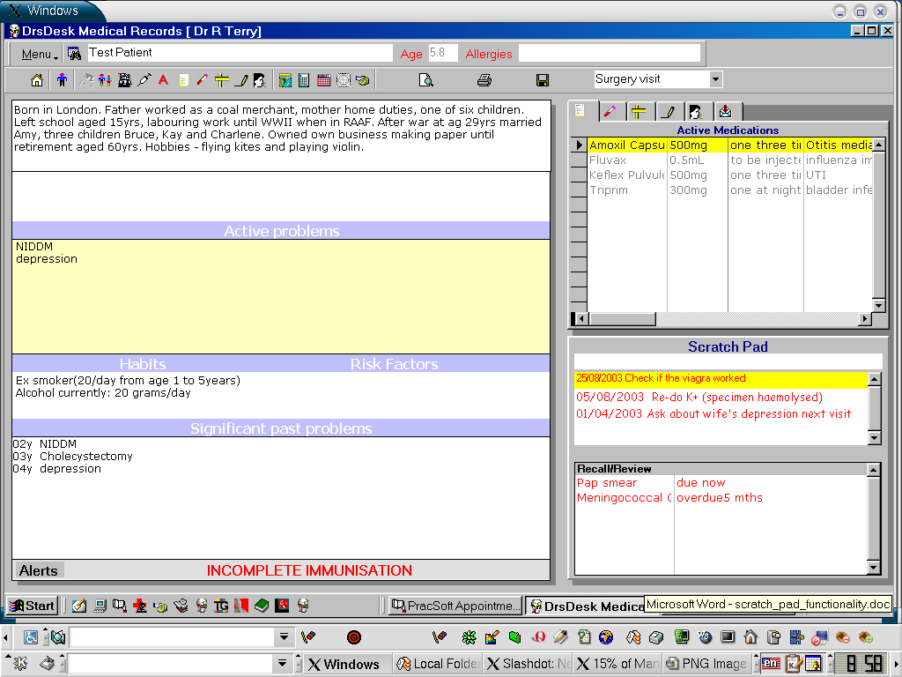

It is one of the least used, but most valuable parts of the program. It is used to enter comments into the medical record which don’t fit anywhere else. The examples above, taken from the records of a disturbed transsexual child with progeria and give some indication of its use. Its really about non-essential prompts or recalls which one doesn’t need to chase the patient about, but still wants to get done next time they arrive at the practice.

GUI-ELEMENTS

Background Panel 3D BGC=RGB 192,192,192

Holding either:

1) txtbox for data entry - BGC = RGB 255,255,255 FGC RGB 0,0,0
- responds to enter key > puts data in scratchpadlist
listbox
- 3D=0 BCG = RGB 255,255,255, FGC = RGB 255,0,0 (red)
- Note same panel holds the recall-review grid/list discussed separately.

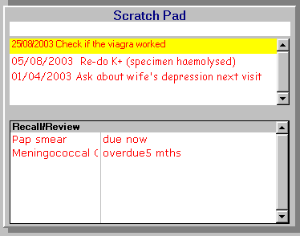

The listbox responds to right mouse click for popup menu:

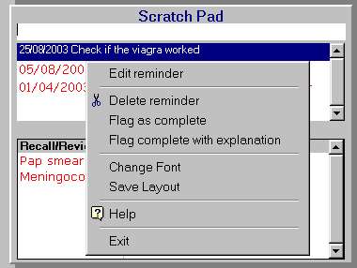

Menu Items:
- Edit retrieves highlighted text to text box and allows editing if inserted in current consultation, otherwise menu label is inactive
- Delete deletes highlighted item if during current consultation otherwise pops up audit-trail form for user to enter explanation as to why it is being deleted for example – sorry about the crappy graphics:

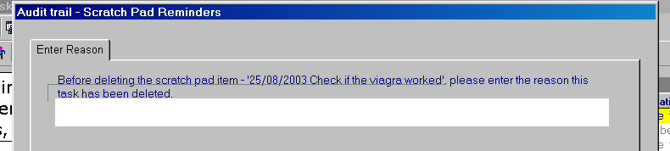

- Flag as complete flags the task as complete without explanation
- Flag complete with explanation flags task complete with explanation
- Change Font allows user to change to custom font for this list control
- Save Layout allows user to save changes to custom list control
- Help displays help file on scratch pad

2) or wxEditableListBox list control which is quite nifty which does the whole thing and edits in the list in-situ.

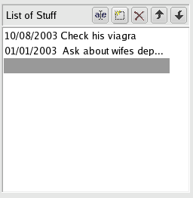

Option 1 with programming to take care of events and pop up menu I think works better overall as it looks cleaner and is better integrated with the overall design concept.

END OF GUI FUNCTION DOCS FOR SCRATCH PAD

